# SIMULATION RESULTS

## R-LOAD SIMULATION RESULTS

## 

Figure 1. The circuit of AC to DC Motor Driver with R Load

THD is equal to %204.

The output voltage and rectifier voltage of system different with duty cycles are shown as follows;

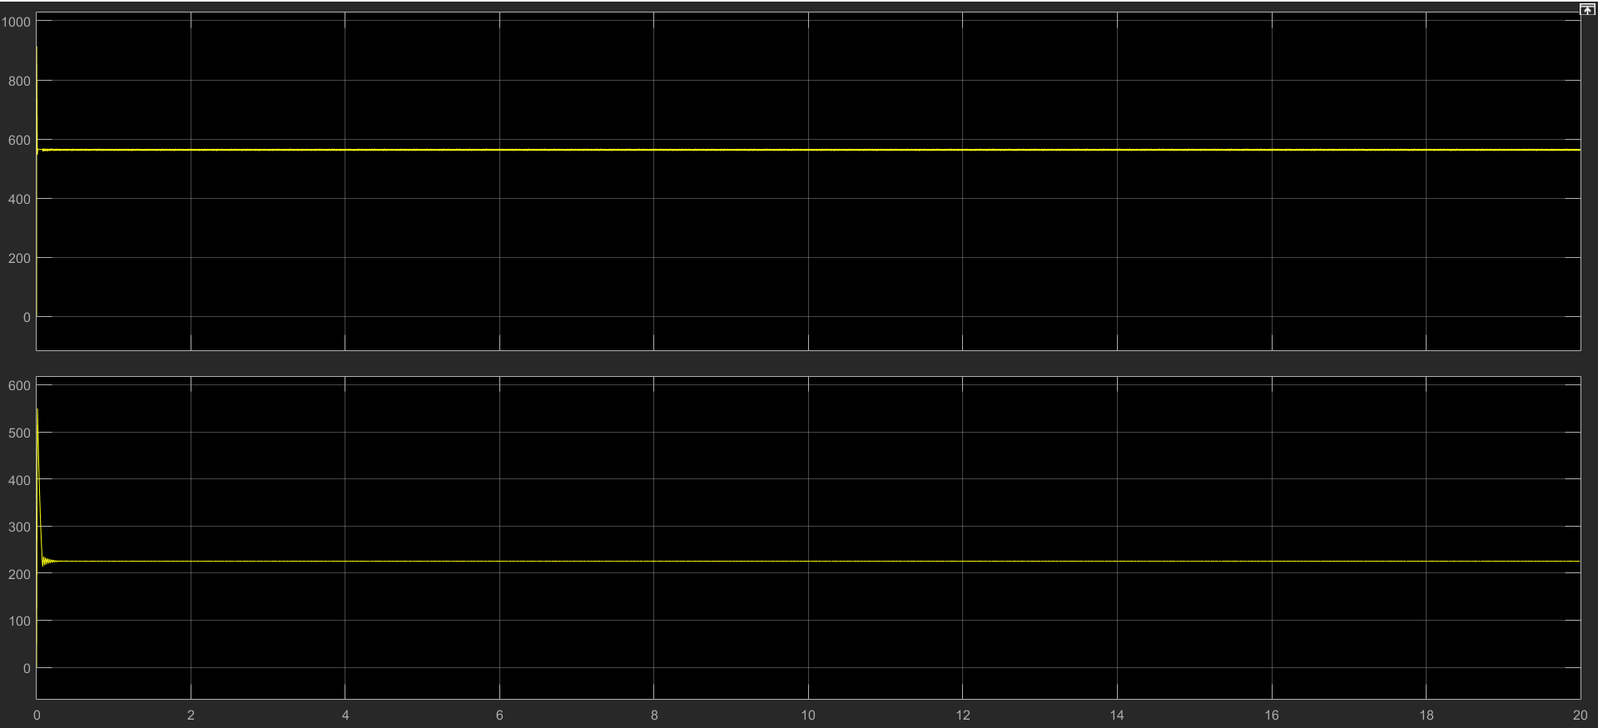

Figure 2.Output Voltage and Rectifier Voltages of R Load at %40 Duty Cycle

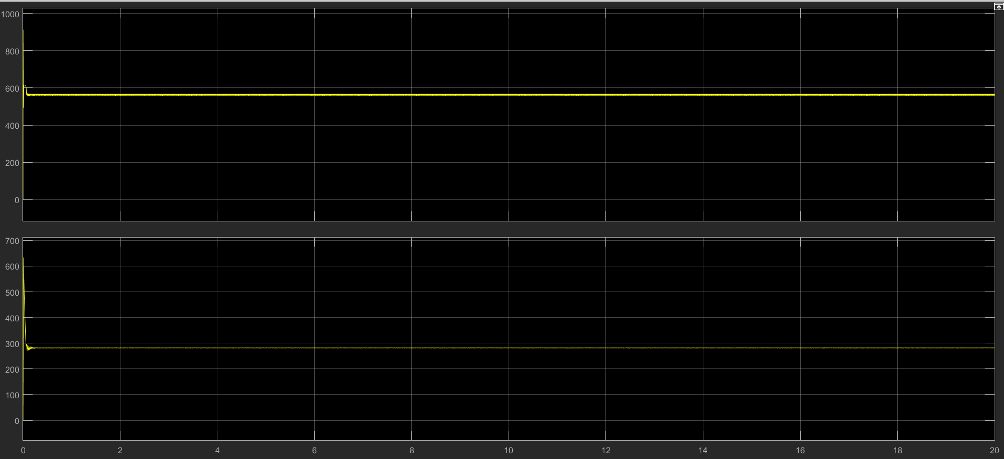

Figure 3.Output Voltage and Rectifier Voltages of R Load at %50 Duty Cycle

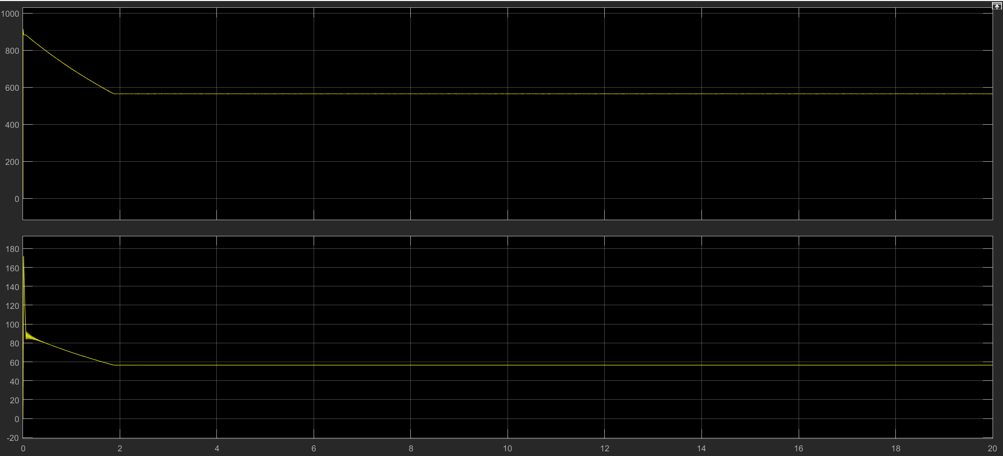

Figure 4.Output Voltage and Rectifier Voltages of R Load at %10 Duty Cycle